**Grind Boxing Gym Newsletter – August-September 2018**

Dear Grind Boxing Gym Members and Friends,

Because of all of you, [Grind Boxing Gym](https://www.prescottgrindboxinggym.com/) has become everything I’d hoped it would be when I opened it in May of 2015. Actually, many of you have helped me take our gym even farther than I expected back then. Your commitment to fitness and reaching your goals as boxers inspires me to expect even more from all our members. In this newsletter I have the privilege of presenting our competitive champions as well as lessons learned from our fitness “champions” – those of you who strive for your best every week.

1. **Grind Champions Win Two More Belts**
2. **Fall Grind Celebration Saturday September 29**
3. 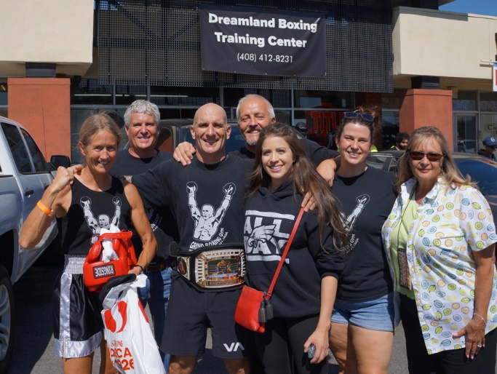**Preparing for Next Competitions**
4. **Grindings – Reaching Your Boxing Goals**

**Grind Champions Win Two More Belts**

The Grind competitive boxing team flew to San Jose, CA for the Dreamland Masters Boxing World Championships September 22 and 23. This was the third competition for both of our competitors, Bill Monastero and Sue Knaup. Grind members, Sara and Keith, as well as Bill’s wife Elisa and my wife Yvonne, came along to help with cornering and capturing the moment on film.

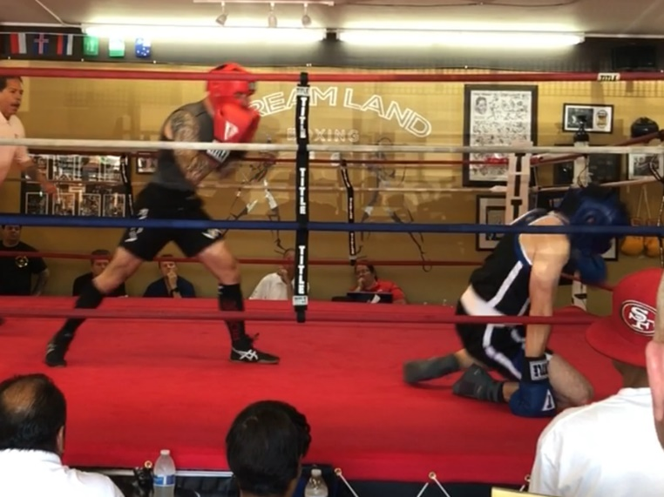The excitement began on Saturday with Bill’s bout. He faced a tough, hard hitting opponent. The first round, both came out punching fast, but from the start Bill was landing the cleaner shots. Seconds into the first round, Bill sent his opponent to the mat with a hard straight left. This guy was tough, though, and got up immediately to fight back. In round two, Bill had to adjust his tactics as I shouted for him to use his right even more. Those rights started landing and his opponent began to slow. By round three, Bill was driving him back with one-two combinations and by the time the final bell rang, he was the clear winner. This is Bill’s third championship belt.

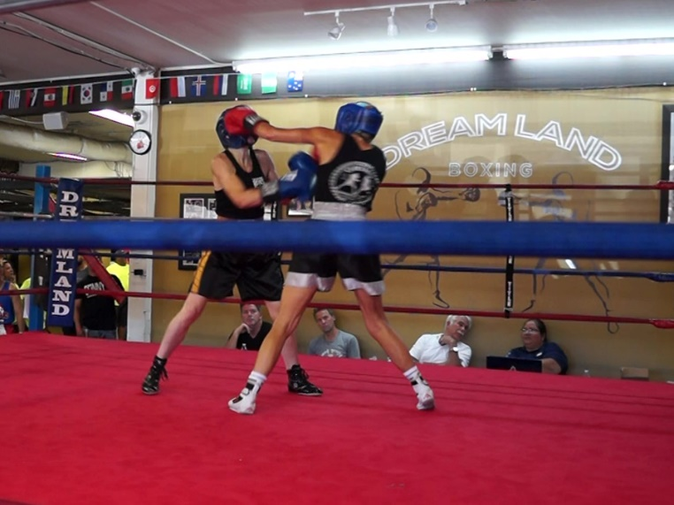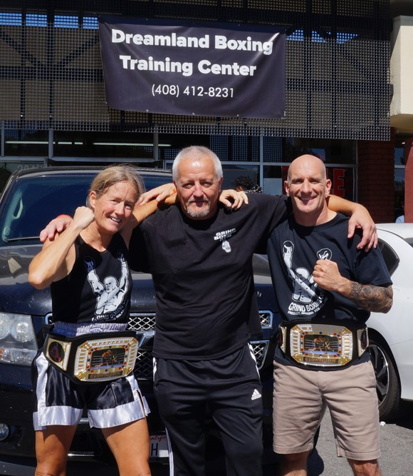Sunday was Sue’s day to compete. She also faced a tough opponent who she’d fought in her first competition last year, a true boxer with a strong stance, accurate punches, and great defenses. Sue had to fight her best and never let up the pressure. In round one, they traded power punches, with Sue landing a few more. In round two, Sue discovered that her straight rights were being blocked so she tried an overhand and that was the key. I started yelling “Over!” and she kept at it. She also threw in some uppercuts that landed and her opponent began to slow down. In round three, we kept to the plan of overhands and uppercuts. Sue moved in more to find better range and power, and that did it. This is also Sue’s third championship belt.

I am so proud of these two champions! Check the [Grind website video page](https://www.prescottgrindboxinggym.com/video) in early October when I will post both these bouts so you can see for yourself.

**Fall Grind Celebration Saturday September 29**

It’s time for our next members’ gathering so we can celebrate the accomplishments of the summer with our longtime and new members.

* **Saturday September 29 starting at 4:00pm at the Rickety Cricket**, 214 S. Montezuma in Prescott.

We’ve got a table reserved outside. Come share your stories from the gym and the competitions and meet other members you might not have met yet.

**Preparing for Next Competitions**

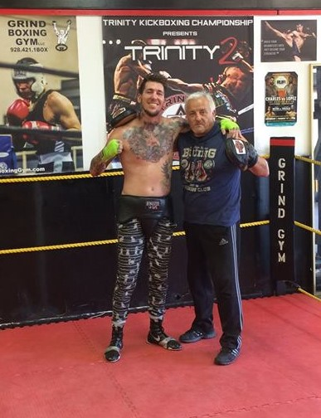

Can you believe that back in 2015 I thought that Grind Boxing Gym would never have competitive boxers? I was quite happy to focus on helping people gain fitness through real boxing training. As this newsletter comes together, I am only four days back from one competition and immediately back to training my competitive members for three more competitions coming up:

* October 13 – we hope to find opponents for Miguel and Luis at a one-day show in Phoenix, AZ.
* November 9-11 – we’ll have up to five boxers competing at the Gene Lewis Invitational Boxing Tournament in Mesa, AZ.
* November 23 – Danny Hilton, our pro MMA fighter, will compete in his first pro boxing competition in New Mexico.

All of these competitors are hard at work refining their technique and honing their conditioning. If you need inspiration, all you have to do is come by the gym on the evenings they are training and see the commitment and determination they are putting forward. Seeing their commitment makes being a boxing coach truly gratifying.

**Grindings – Reaching Your Boxing Goals**

Since starting as a boxer and kickboxer when I was a teenager (that’s over 40 years ago), then becoming a boxing coach, I have observed all sorts of boxers. Most are happy to focus on the initial stages of boxing training. Only a few find the commitment needed to compete. But even the initial stages of boxing training are more demanding than any other sport, and more rewarding. That is why the main focus of [Grind Boxing Gym](https://www.prescottgrindboxinggym.com) is for anyone wanting to get fit through real boxing training.

Unfortunately, wanting to get fit and actually reaching fitness are two very different things. Over the years, I have watched too many people set ambitious goals only to give up. It’s usually a slow process that starts with easing up during their workouts, maybe even sitting down or spending gym time talking. Then they show up fewer times each week and then finally vanish.

Each disappearance hurts me because I want every Grind member to reach and stay with their goals, whether for fitness or competition. So I’m going to offer some tips here.

First and most important is consistency. Prioritize and schedule your boxing training in your life and don’t allow less important things to get in the way. If you have joined Grind for fitness, then come at least twice a week, but three times is better. If you can only come once per week, you will not see much improvement. If you plan to compete, don’t even think of coming to the gym fewer than three times per week! Once you are in the gym, make every moment count. Focus on your technique and push your conditioning.

In order to improve your fitness and boxing skills, you must push past your current state. Imagine yourself at your peak performance within the goal you have set. See and feel yourself in that state of fitness. Write down your goal using vivid descriptions so that even if you get a bit lost in your training, you can find your focus through your written goal. Check it weekly to ensure you are improving step by step.

If something stops you from training, do not dwell on this setback. Simply start again where you are and move ahead step by step always keeping your ultimate goal in mind.

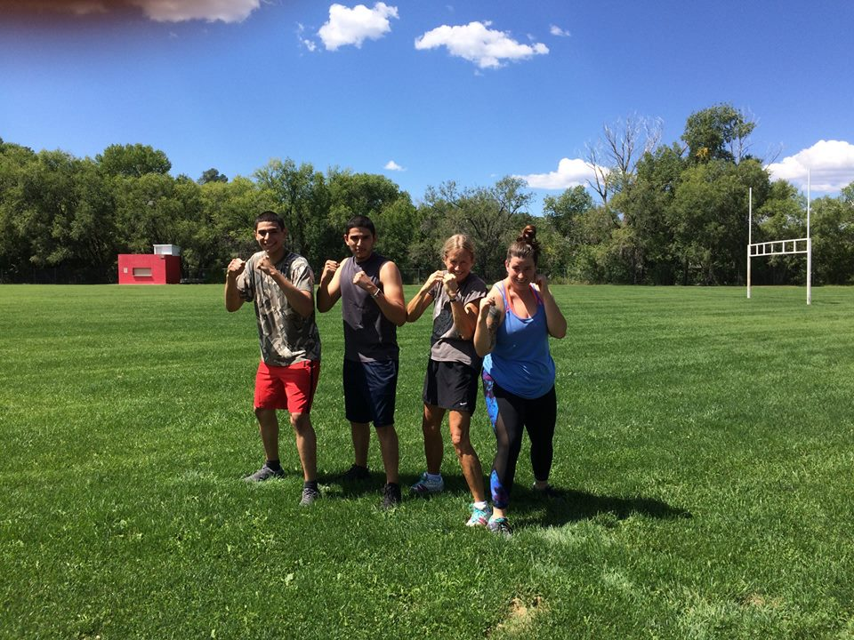

Be realistic, but don’t set your goal too low. Be bold. Train at your 100%, then push a bit more. This is how you will improve. My most successful boxers always give that extra push. They come to the gym even when they are tired. They add strength training at home. They add running, jump roping, and Hindu squats to their daily routines outside of the gym. They eat well and avoid junk food that slows them down.

Only you will know when you have reached the necessary consistency and commitment to reach your training goal and only you can hold yourself to it. But I am here to help you at every step. If you find that you are struggling to improve, talk to me about it. I am eager to help you get back on track because my ultimate goal is for all Grind members to succeed.

Coach Jarek Slagowski